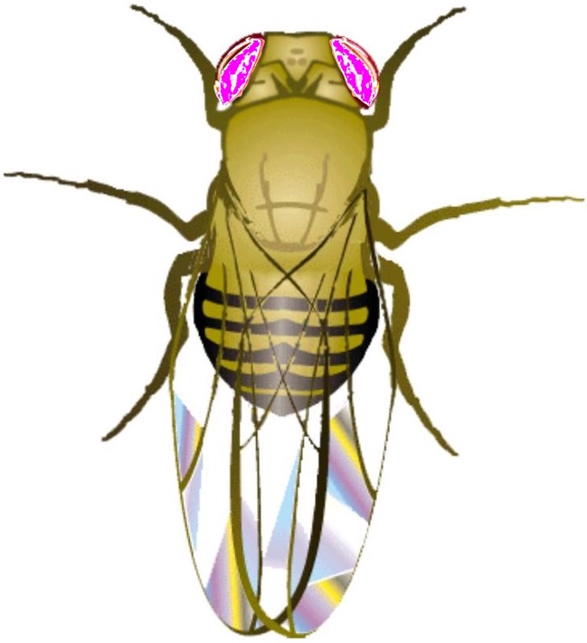

MRU Open

Genetics Lectures

Part one – Classical Genetics

Note that this is organized to set up online exercises at http://opengenetics.net

This project was funded by the Alberta Open Educational Resources (ABOER) Initiative, which is made possible through an investment from the Alberta government

OPEN GENETICS History
The first edition of this textbook, called OPEN GENETICS, was produced in January, 2009 as instructional material for students in Biology 207 at the University of Alberta, and is released to the public for noncommercial use under the Creative Commons License (See below). Users are encouraged to make modifications and improvements to the book. All the text in the original 2009 edition was written by Michael Deyholos, Ph.D. In subsequent editions (2010-2014), additional chapters were written by Mike Harrington, Ph.D., at the University of Alberta. Additional content and editing by John Locke, Ph.D. and Mark Wolansky, M.Sc., at the University of Alberta. Photos and some diagrams were obtained from various, non-copyrighted sources, including Flickr, Wikipedia, Public Library of Science, and Wikimedia Commons. Photo attributions are listed in the legend with each image.

Open Genetic Lectures (OGL) Origin: 2015
OGL is an alternative approach to an open source textbook. Much of its content is derived from the OG textbook. The 13 chapters in OG were cut up and distributed into 41 shorter chapters that parallel the current lecture topics in BIOL 207 (Molecular Genetics and Heredity) at the University of Alberta. More text content, figures, and chapter-end questions were added in this revision.

This reorganization of OG content into OGL was accomplished during the summer of 2015 by John Locke, Mike Harrington, Lindsay Canham, and Min Ku Kang. Lindsay Canham was supported by a grant from the Alberta Open Education Initiative (OEI) through the University of Alberta. Min Ku Kang was supported by a Summer Student Scholarship from the Centre for Teaching and Learning (CTL), University of Alberta. Without these sources of financial aid this project would not have been possible. John Locke and Michael Harrington appreciate their help, as well as that of Michael Deyholos, who initiated this endeavor.

Todd Nickle re-ordered some chapters to correspond with the sequence he uses in class and to relate to the online activity site http://opengenetics.net.

In the future, molecular chapters will be incorporated into the text. For now, they are individual files not included in this booklet.
Access to OGL (MRU) text files
The final versions of this work and the website are available as .zip files at http://opengenetics.net/Files

They include all the .docx, .indd (InDesign), css, .html, and image files for each chapter and other relevant files. They are available for anyone to use, adapt, or improve for educational purposes. If you have edits, improvements or additions that you wish to share under the same license terms, please contact John Locke, University of Alberta or Todd Nickle, Mount Royal University (tnickle@mtroyal.ca).

